mysql> use mydb;

Database changed

mysql>select*from sorni;

Empty set(0.00 sec)



mysql> insert into sorni values('sornesh', 19221, 17);

Query OK, 1 row affected (0.01 sec)

mysql> insert into sorni values('sorni', 19222, 17);

Query OK, 1 row affected (0.01 sec)

mysql>select*from sorni;

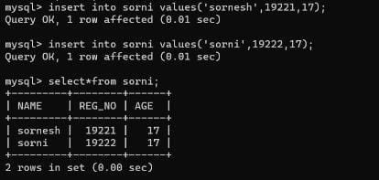

mysql> alter table sorni add primary key (REG_NO);

Query OK, 0 rows affected (0.08 sec)

Records:0 Duplicates: 0 Warnings: 0



mysql>select*from sorni;

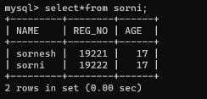

﻿

mysql> alter table sorni add COURSE char(10);

Query OK, 0 rows affected (0.01 sec)

Records:0 Duplicates: 0 Warnings: 0



mysql> update sorni set course='CSE';

Query OK, 2 rows affected (0.00 sec)

Rows matched: 2 Changed: 2 Warnings: 0

mysql> select from sorni;

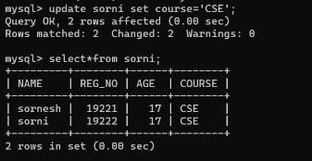

mysql> create table sports (NAME char(50), SPORTS char(50), REG_NO int, foreign key (REG_NO) references sorni(REG_NO));

Query OK, 0 rows affected (0.05 sec)

mysql> desc sports;

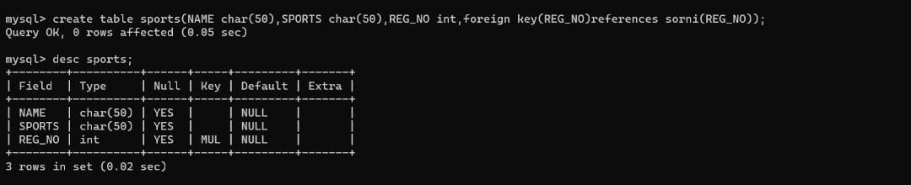

mysql>alter table sports add unique (sports);

Query OK, 0 rows affected (0.02 sec)

Records:0 Duplicates: 0 Warnings: 0



mysql>alter table sports add column (AGE int);

Query OK, 0 rows affected (0.01 sec)

Records:0 Duplicates: 0 Warnings: 0



mysql>alter table sports add check (AGE >=18);

Query OK, 0 rows affected (0.06 sec)

Records:0 Duplicates: 0 Warnings: 0



mysql>desc sports;

